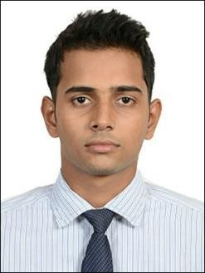
RESUME
MUHAMMED FASIL T K
Thorakkattil House Alanallur Post
Mannarkkad (Via), Palakkad(Dist). Kerala, India – 678601
Mobile: +91 7994193232 E-Mail:fasil7994193232@gmail.com
PERSONAL DETAILS
Name : MUHAMMED FASIL T K
Date of birth : 29th Aug 1996
Father’s Name : Musthafa
Sex : Male
Marital status : Single
Nationality : Indian
Religion/Caste : Islam/Mappila
Languages Known : English, Hindi, Tamil, Malayalam

EDUCATION QUALIFICATION
- SSLC from Board of Public Examinations, Kerala.
- Plus Two from Board of Public Examinations, Kerala.
- BBA from Bharathiar University, Tamilnadu.
- IATA (Airline and Airports Handling Management).

COMPUTER SKILLS
- Auto CADD
- MS OFFICE WORK EXPERIENCE
- 3 Months Training experience as Ground Handling at Calicut Airport.
- 2 Years Salesman experience at Casio Gift Palace Bangalore. PASSPORT DETAILS
Passport No : K3060503
Issue Date : 16-05-2012
Expiry Date : 15-05-2022
DECLARATION
I hereby confirm all the points noted above are true and correct to best of my knowledge and belief.
Yours faithfully,
Place :
Date: MUHAMMED FASIL T K
1

