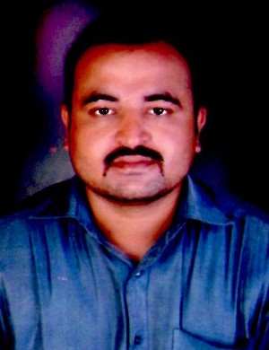

CURRICULAM VITAE
Er. Kulkarni Yogesh Anil B. Tech. (Agril. Engg.)

Address : A/P- Aghar (kh), Tal- Malegaon,

Dist- Nasik, PIN- 423203 (Maharashtra).
Contact No : 8669096842
Email : Kulkarniyogesh92@gmail.com

Objective: Looking for an opportunity which brings out the best of my Talent and Lead a Challenging career and serve for the upliftment of the Agro-economic World.

Personal Information;
Name in Full : Kulkarni Yogesh Anil
Father’s Name : Shri. Kulkarni Anil Vitthal
Date of Birth : 26thMarch 1989
Religion and Cast : Hindu – Brahmin
Nationality : Indian
State Of Domicile : Maharashtra
Native Place : Aghar (kh).
Material Status : Married
Sex : Male

Permanent Address : A/P- Aghar (kh), Tal- Malegaon,

Dist. - Nasik, PIN- 423203 (Maharashtra).

Educational Qualifications

Examination | Year | Board / University | Aggregate
S.S.C | 2003-2004 | Nasik (MH) | 73.86%
H.S.C | 2005-2006 | Nasik (MH) | 62.74%
B.Tech.  (Agril.Engg.) | 2009-2010 | M.P.K.V. Rahuri | 72.50%

Work Experience:
- Having one year & two month’s job experience as a Sales Officer in Parixit Industries Limited at Solapur, Pune & Dhule districts.
- Having four years working in Netafim Irrigation India Pvt. Ltd. as Sr. Officer sales & Marketing at Solapur, Pune & Nashik districts from Oct-2011 to April-2017 and worked as District manager from April 2017-April 2019 for Solapur district
- Currently working as Sales Manager in Rivulis irrigation for Western Maharashtra and Marathwada region since 2 May 2019

Special Academic Achievement;
- Summer Trainings:
Period | Training Center | Title | Department | Duration
2-06-2008 to 30-06-2008 | Water & land management institute, (WALMI) Aurangabad (MH). | Soil & water conservation | SWCE | One Month
02-06-2009 to 30-06-2009 | Central institute of Post Harvest Engg. & Technology (CIPHET), Abohar (Punjab) | Post harvest engg. Of horticultural crops. | APE | One Month
Special Job Achievements:
Got two times Best Employee award for Automation & PC products sales in Netafim Irrigation India Pvt. Ltd for the year 2014 & 2015.
First Netbeat automation system of Netafim sale in India in 2019.

Academic Project Carried Out:
- “Performance evaluation of Solar Air Heater.” (Under Renewable Energy Depertment)

Extra Curricular Activities:
- Certificate course in MS-CIT.
- Participate in additional State level NSS camp. (22 Sept. to 2 oct. 2008).
- Gold medal in 1st Senior State Championship of KICKBALL (2009).

Declaration:
I hereby declare that all the information provided above is true to the best of my knowledge and if proven wrong, I will be responsible for any further action taken against me.

Place : Pune (M.S.) ,

Date: / / 2023

Kulkarni Yogesh Anil

