An B.Sc (Biology) from Ravi Shankar Shukla University from Raipur (C.G.), I am looking for opportunities to work in Seals & Marketing Business Development and Operations. I have a good experience working for Corporate as well as Government organizations. I am diligent, a task master and work well in teams as well as individual contributor roles. in me to learn new things and filed complete a task with confidence which is my strength.

EXPERIENCE
March 2022 – August 2022

ASSISTANT MANAGER AGRI- OUTPUT (FNV) 
● Working in Green Agrevolution Pvt Ltd Gurugram Hariyana- DeHaat from 10th march 2022 to 3rd
August 2022 in the location of Chhattisgarh at Raipur as the post of Assistant manager of operations in Agri output business. In DeHaat I work to on-board buyer and supplier in all over Chhattisgarh. In selected commodity in FnV.

March 2021 – March 2022
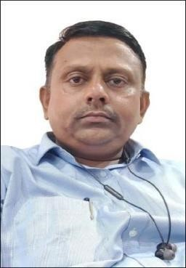
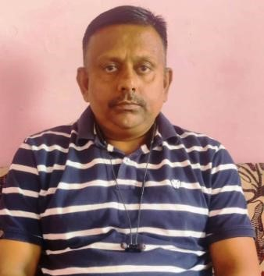
ASSISTANT MANAGER AGRI- OUTPUT (FNV)  ●Working in Krishi Acharya technology Pvt Ltd #Bijak from 1st march 2021 to 10th March 2022, in the location at Raipur Chhattisgarh in the post of assistant manager of operations on board in Mandi to buyers, loaders, and Farmers. Working in my territory on thetrading side and supply side to all vegetables, Onion, potatoes at the Raipur Chhattisgarh Mandi.
H.

Vasim

Sajid

Add: Nijami Chowk Sanjay Nagar Raipur (C.G)

Phone

–

99811
61311

/ 9340091081.

Email:

hvsajid@gmail.com

Januray - 2017 – November - 2020

SOLAR PUMP Sales 3HP to 5HP
/SOLAR COLD STORAGE 5 Ton  ●Worked in Ecozen solutions Pvt Ltd - Raipur (C.G.) and head office Pune (MH) in solar pump sales 03 HP and 05 HP / solar cold storage Sales installation handing in government Departments , and individual farmar in distric level. Process and Installation in @700 Pumps in 2 year in selected district in
Chhattisgarh state.In solar cold storage segment our rental model / sale mode working in different crops likes fruits vegetables and flowers in all India sourcing side and all pocket. Like strawberry Cherry custard apple green chilli coriander and Litchi Bihar .

January 2016 – January 2017

Assistant manager sales 
Chhattisgarh, odisha state location
● Work in Neptune packaging Indore (M.P.) in Marketing 10th Jan 2016 to Jan 15th, 2017.In the Neptune I am handling to Chhattisgarh market , Odisha market and some part of MP to sales and business development in Agri input business.

February 2013 – December 2015
Sales executive – Agri machinery all chhattisgarh state 
● Work in Kisan Kraft machine tools Bangalore in Marketing 15th Fub.2013 to Dec 31th 2015 as a marketing educative all Chhattisgarh to Mack dealer distributor and also make the government sale in Chhattisgarh Region. Kisan craft is a importer he import to all Agri Small implement to China and sale Pan india location.

January 2012– January 2013
Sales executive – Postpaid sales Raipur location  ● worked in Vodafone postpaid sales in 2012 up to 2013 date company is leading work in telecom sector in MP+CG.

January 2011– January 2013
Sales executive – Postpaid sales Raipur location
● Work in AIRCEL telecom in postpaid sales in 2011 up 2013 date company is leading work in telecom sector

March 2010– January 2013
Sales executive – Digital and Data sales Raipur location
● Ortel Communication Ltd. One of the Leading telecom company in Broadband and Digital T.V.
Services as a Sales Since (March 2010)
●Worked in Tata Indicom One of the leading telecom company in landline Services as Field Work in Willkie Phone Sales.
●Worked in K.B. Agency One of the medicines (CNDF) agency in working in Dulux Paint Company in Raipur

EDUCATION

ACADEMIC PROFILE: -
- B.sc (Biology) from C.G. Pt.R.S.S. University (2000) IInd Div.
- 12th from MP Board Bhopal (1997)1st Div.62%
- 10th from MP Board Bhopal (1995) Div.64%

SKILLS
- MS Office functional and working knowledge
- Good communication skills
- Good resource management skills at all levels
- Efficient negotiator
- Team player
- New Learning and create new ideas and execute it

KEY RESPONSIBILITES
- Meet the targets on a monthly basis.
- Handling key accounts and direct sales.
- Responsible for identifying need of the right customer and • responsible for planning assistance solution.
- To Provide excellent customer service.
- To provide quick response to customer queries.
- Eve filling of application and focus on all product categories strict adherence to sales process.
- To gain customers confidence to manage his/her complete portfolio.
- Telemarketing calls to prospective clients and develop market through a process of continuous prospecting.
- Responsible for educating the prospects about our products viz-a-viz competitor products.
- Ability to think creatively, cohesively, independently.

ACTIVITIES
- NCC best cadets in my school time.
- State runner ranking in lawn tennis tournament Association. • Core Member of Jagadalapur college Cultural Fests.

PERSONAL INFORMATION
- Date of Birth – 04/05/1980.
- Current Address – 40/336 Sanjay Nagar Tikrapara Raipur distc Raipur chhattisgarh.
- Permanent Address – Near Gayatri Mandir village and Post – Chhura Dist Gariyaband 496996,
- Father’s Name: shri Mohammad Salim sajid
- Mother’s Name: shrimati Jamila sajid
- Nationality: Indian
- Languages: Hindi, English, chhattisgarhi.
- Interests and Hobbies: Lawn Tennis, Badminton, old song’s and Travelling

Declaration : -
I Hereby declare that the above-mentioned information is correct up to my knowledge and I hear the responsibility for the above- mentioned particulars.
Date: .................
Place: At Raipur (C.G.)
(Signature)

