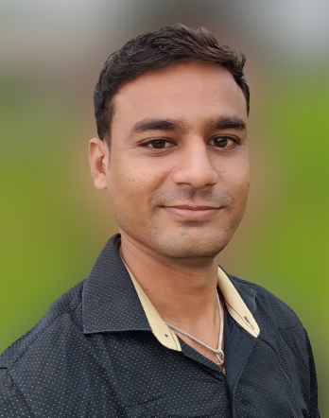 |  | EDUCATION
Diploma In Industrial Electronics

Course | University | Year | Percentage
Diploma | MSBTE Mumbai | 2015 | 63.52 %
S. S. C. | Nashik | 2007 | 58.46 %

Swapnil Narendra  Patil  (Service Engineer)  Profile  Seeking further challenges where my knowledge could be utilized for the mutual benefit of the organization and for myself with upgrading my knowledge as per the organization’s expectation and changing times.  CONTACT  Mobile -  +91-9922370888  Email -  Swapnilpatil2929@gmail.com  address:  At Post - Gorgawale Bk, Tal-Chopda, Dist. -Jalgaon  Pin -425107. |  | WORK EXPERIENCE
As Service Engineer From (Oct 2018 to Jan 2020)
- at Aplab Limited. Waghale Estate Thane.

Job Profile:
Worked as service engineer to provide day to day maintenance to self-pass book printer machine of nationalize Bank of Baroda. In North Maharashtra region.

I was responsible to provide service to the bank self-passbook printer machine if any repair or replacement required.

As per the contract with vendors, I was doing regular checkup of all working machines as part of preventive maintenance.

 |  | SKILLS
- Hardware & Networking.
- CNC machine coadding & Operating
- PLC System

Strengths:
- Result oriented and Self Motivator.
- Team player as well as individual performer.
- Adaptable and Fast Learner.

