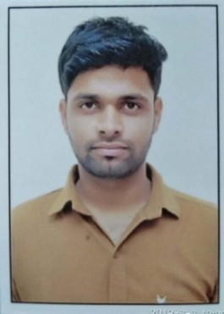
CURRICULUM VITAE

NAME: Sunil Das Bairagee
EMAIL: sunilbairagee94@gmail.com
CONTACT No.: - 9098993674

Career objective
Seeking a position to utilize my skills and abilities in the Horticulture sector and to excel through diligence and learning ability and utilizing my skills to make valuable contribution to the organization.

Educational Background

Year | Examination | Institution | Board/University | %
2018 | B.Sc.  (Horticulture) | College of Horticulture Mandsaur, MP | RVSKVV Gwalior M.P. | 69.8
2013 | Mathematics stream  12th | Nav Jagrati High School, Bani  Mandsaur (M.P.) | MPBSE Bhopal M.P. | 63.00
2011 | 10th | Nav Jagrati High School, Bani, Mandsaur (M.P.) | MPBSE Bhopal M.P. | 82.33
2018 | Diploma in Computer Application | Sunrise Institute Mandsaur (M.P) | Makhanlal Chaturvedi National University of Journalism and Communication  Bhopal | 55.71%

Experience
.
- Feb 2020 – Oct 2020: - Agstack Technologies Pvt. Ltd.

- Sep 2019 – Jan 2020: - T. Stanes Company Ltd.

- 6 months training experience in (RHWE) “RURAL HORTICULTURAL WORK EXPERIENCE” and
(HIA) “HORTI-INDUSTRIAL ATTACHMENT” as a part of degree program.

- 6 months “EXPERIENTIAL LEARNING PROGRAMME” (ELP) under PROTECTED CULTIVATION OF
HIGH VALUE HORTICULTURAL CROPS and FLORICULTURE & LANDSCAPE GARDENING as a part
of degree program

Extra-Curricular
- Participated in sports and cultural activities in school and college.

Personal Details

Name | Sunil Das Bairagee
Father name | Shri Narsingh Das Ji Bairagee
Date of Birth | 08/08/1996
Current address | Mandsaur (M.P.)
Permanent Address | Village- Bani, Post - Bani, Teh.- Daloda, Dist.  Mandsaur (M.P.) 458667
Nationality | Indian
Language Known | Hindi and English

Declaration
I hereby declare that the above information is true the best of my knowledge and I bear the responsibility for any wrong information if specified.

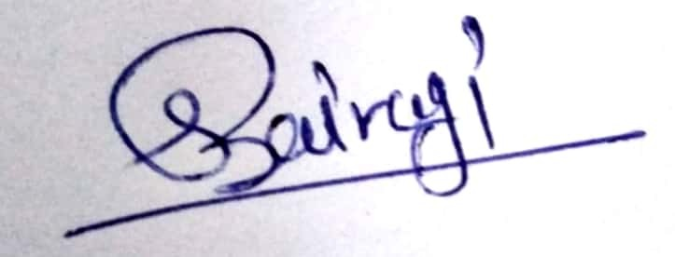
Yours Sincerely
Sunil Bairagee

