Contact
Address:
2/2, Girija Shankar Patel Compound, Shivaji Nagar, Kurar Village, Malad (East), Mumbai - 400097

Phone:
9664782301

Email:
sanskrutimdhumal@gmail.com

LinkedIn:

About :
DOB : 19/11/1993
Marital Status: Married

Languages
English
Hindi
Marathi

Hobbies
- Writing
- Dancing
- Singing

Summary
Taking care of cash & fund management for PAN India level in current organisation, preparation of cost sheets for 3PL. Experience of 9 yearse in day to day accounts entries & requirements. Worked in Tally ERP 9, Baseone software, Openbravo Software, etc. Always ready to learning new things. Believes in friendly nature & environment rather than hostile,adjective environment.

Skill Highlights
- Fund Management  - Cash Management  - Warehouse & logistic knowledge  - Hard Working | - Quick Decision Maker  - Interest in new learning  - Problem resolver  - Time Management  - Team Mangament

Experience
Account Sr. Executive – 07/05/2015 to 15th Feb 2024
Parekh Integrated Services Pvt Ltd.
- Cost sheet preparation for the new enquiries for warehousing & logistic
- All operational & warehousing knowledge for the third party logistics
- Agreement renewal of principle companies with analysing profit & loss
- Purchase invoice raised for Principle Companies (Debit note)
- Claim process to take reimbursement from the principle compnies
- Ho Banking – Handling funds transfer for requirement of various activities & branches of Parekh & other group business for their day to day activities
- Daily collection report & fund requirement report creation
- Bank Reconciliation & Daily cash budget prepare
- Overall review of all over India petty cash account & cash collection accounts
- Daily cash budget prepare

Power print Cartridges Pvt Ltd. ”. as a Account Executive 1.5 Year.. (Sales & all received payment, Purchase & vendor payment, Banking, Salary, Expenses vouchers.)

Rajesh Modi & Associates (C. A Firm)- as a Account Executive - 2 years

Education
- CMA final exam appearing Dec 2024
- MBA Finance from Mumbai University. (2018-2021)

Certifications
- Office Automation Cour
- Tally – 7.2 ,9, ERP 9
- MSCIT
- Typing - English 40 wpm & Marathi 30 wpm

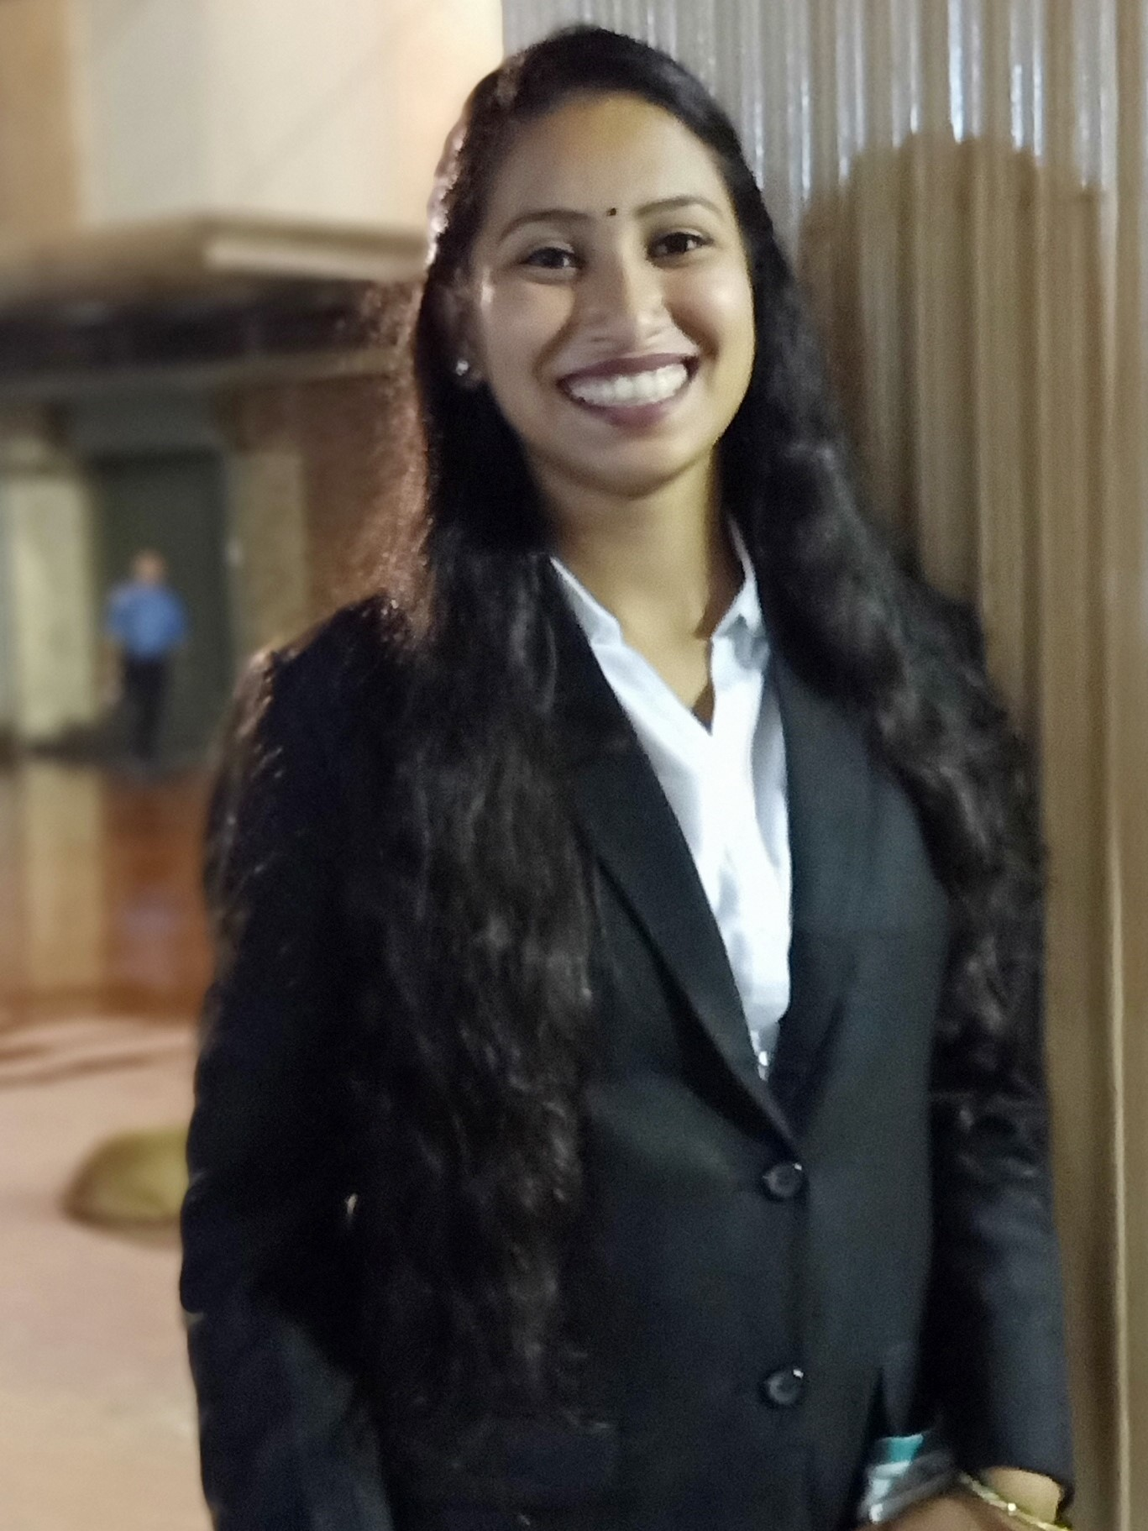
Sanskruti Dhumal

