CURRICULAM VITAE 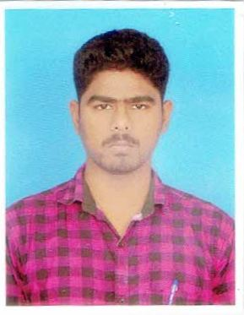
RIYASUDEEN
NO: 3/3 Muslim Otthavadi Street,
Factory Road,
Nellikuppam-607105 Email: riyasmage@gmail.com
Cuddalore-Dt PH: +91-9092025993

OBJECTIVES:
- To obtain a position that will enable to use my strong organizational skills, and first class for my curriculum or ability to work well with people.
- Seeking a position as a clinical practice assistant for health projects and good well in medical terms or project management.
EDUCATION QUALIFICATIONS:
Degrees/  Standards | Institute | Board/University | Year | Percentage
MSW(CD) | Periyar Govt Arts College | Thiruvalluvar University | 2015-2017 | 68%
D.M.L.T | Fathimaa Paramedical Institute | Bharath Seva Samaj | 2013-2015 | 83%
Bsc(Micro biology | ST.Joseph Arts And Science College | Thiruvalluvar University | 2011-2014 | 52%
Hsc | Danish Mission Higher Sec School | State Board | 2009-2011 | 57%
S.S.L.C | Danish Mission Higher Sec School | State Board | 2009 | 51%

AREA OF INTEREST:
- Admin and Organization Skills.
- Community Development
- Training and Development
- Relief and Rehabilitation
- Leadership
- Counseling
- Field and Monitoring
- Advocacy
EXPERIENCE:
S.NO | COMPANY/ORGANIZATIONS | ROLE/DESIGNATION | FROM | TO
1 | Linga chemicals, Madurai | Field Officer, Agriculture | Jun-2019 | July-2021
2 | Adama India pvt limted | Marketing development | Aagust-2021 | Present
RAPID RESPONSE DISASTER RELIEF AGENCY
- BIHAR FLOOD RELIEF PROJECT
- VARDAH CYCLONE PROJECT
- KERALA FLOOD RELIEF
PARTICIPATE IN CONFERENCE AND SEMINARS:
1, National seminar on Implication of social work practices in disaster preparedness and risk management held at St. Joseph’s college Arts and Science (autonomous) Cuddalore on 8 February 2017.
2, national summit on climate change & disaster risk reduction conducted by CII (confederation of Indian industry) sponsored by UNICEF held at taj coramondel, Chennai 11-12 April 2017.

FIELD WORK:
FIELD WORK:
AGENCY NAME : RAPID RESPONSE
LOCATION : CUDDALORE AND PONDICHERRY
AGENCY SUPERVISOR : MOHAMED FARUKH
DURATION : 1 Month
AGENCY NAME : CSD (CENTER FOR SUSTAINABLE DEVELOPMENT
LOCATION : CUDDALORE
AGENCY SUPERVISOR : MR. K. ARUMUGAM
DURATION : 1 Month

PERSONAL PROFILE:
NAME : M.Y.RIYASUDEEN
FATHER NAME : MOHAMED YUNIS
MOTHER NAME : SHAMSHIRA BEGUM
SPOUSE : MAGESWARI
DATE OF BITH : 26/06/1993
ADDRESS : 3/3 Otravadi Street, Factory Road,
Nellikuppam, Panruti Tk,
Cuddalore Dt.
MOB NO : +919092025993
Email ID : riyasmage@gmail.com
PASSPORT NO : S6220829

DECLARATION:
I do hereby declare that all the information given above is true to the best of my knowledge and belief.

DATE: SIGNATURE
PLACE: M.Y.RIYASUDEEN

