PRAVEEN.P.MENON 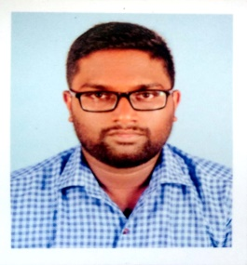

E-mail: prvnmenon94@gmail.com
Mobile: 8129379995

OBJECTIVE:-

To learn and function effectively in an organization and be able to deliver the bottom-line. To constantly upgrade my knowledge and skills and make a difference in whatever I do.

ACADEMIC CHRONICLE:-

Academic Qualification | Institution | Board | Year | Percentage
M.B.A.Interanational  Business management | ACE, College,  palakkad | Bharathiar University | 2016 | 60
B.Sc.Electronics & communication system | AJK CAS, Coimbatore | Bharathiar University | 2013 | 70
HSC | K.C.P.H.S.S,  Kavassery. | Kerala State | 2010 | 60
SSLC | B.S.S.GURUKULAM  H.S, ALATHUR. | Kerala State | 2008 | 80
TECHNICAL SKILLS
- Computer Basics
- Internet Basics
- C & C++ Programming
- MS Office
- Java Programming

AREA OF INTEREST
- Travelling
- Marketing
- Electronics
- Networking

EXTRA CURRICULAR ACTIVITIES
- Have participated in various games and examinations in schools and won certificates.
WORK EXPERIENCE

- Worked as Marketing Executive in DHARANI PUMPS from August 2016 to 2018.
- Worked as Marketing Executive in C.R.I.PUMPS.PVT LTD from April 2018 to 2022.
- Worked as Territory Growth manager in Ashirvad Pipes from January 2022 to 2023.

JOB RESPONSIBILITIES

- Organizing channel sales.
- Managing & Handling Distributors and dealers for increase business volume and share.
- Sales planning and follow up to ensure achievement of monthly targets.

PERSONAL INFORMATION:-

- Date of Birth : 30-05-1992
- Gender : Male
- Father’s name : Padmanabhan.T
- Mother’s name : Padmini.M
- Mother tongue : Malayalam
- Nationality : Indian
- Marital Status : Single
- Hobbies : Watching TV, Traveling, Finding New Friends
- Languages Known : English, Hindi, Tamil, Malayalam
- Permanent address : PRAVEEN.P.MENON
SARADHA MANDHIRAM, TARUR,
PALAKKAD.
DECLARATION:-

I do hereby declare that the above mentioned details pertaining to me are true to the best of my knowledge.

Date: 30/11/2023
Signature

