CURRICULUM VITAE

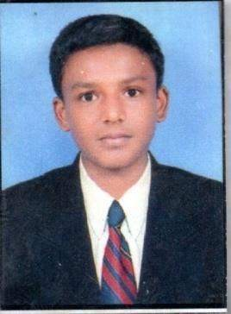
PATEL PRERAKKUMAR
Add- Shivam Tower, Cd-21, wing-f. Pandesara, Bhedvad Surat

TA: - Choryasi-

+91-9106397481
patelprerak0887@gmail.com

Objective To ensure challenging position in a growing organization where I would be ableto utilize my capabilities to the best extend and in the process add value to the organization and my career.
Academic Profile

Course | Board\University | Year | Percentage
Diploma  (Mechanical engineering) | Gujarat Technological University | 2017 | C G P A -7. 0 9
SSC | Gujarat Secondary & Higher Secondary Education Board, Gandhinagar | 2014 | 63.08%

EXPERIENCE
- Worked as computer operator in Hyundai Navjivan Motor Pvt. Ltd.(Surat) serviced for 2 year
- Worked as manufacturing department ashahi India glass ltd (Radhanpur) serviced for 6months
- Worked as quality control department adani solar park (mudra )serviced for 8 month

ACHIVEMNT
- -Training Certificate of NSS
- -Represented college at various compilations
- - 1 Week training at Adani Solar Power

TECHNICAL
SKILL ACQUIRED
 Knowledge of various programming languages like C & C++.

NON-TECHNICAL
Able to lead the team in any stressful situation. Able to take any decision in tough situations.
AREA OF INTEREST
Quality control Production
Manufacturing

PROJECTS
-“Modification and development of ABRESIVE AIR JET MACHINE.”, at SWAMI SACHIANANAD POLITECHANIC COLLEG.
-“MODIFICATION OF ABRESIVE AIR JET MACHINE at SWAMI SACHIANAND

Personal Details

NAME - PATEL PRERAKKUMAR
DATE OF BRITH - 31TH MARCH, 1999
EMAIL - PatelPrerak0887@gmail.com
MARRIED SATUS - MARRIED NATIONALITY
INDIANCAST AND RELIGION -HINDU
HOBBIES - Reading books, playing cricket, LANGUAGE KNOWN - ENGLISH, HINDI, GUJARATI

Declaration I hereby declare that all the information mentioned above is true and complete
To the best of my knowledge and belief.

Date:

Place: (you’re faithfully)

