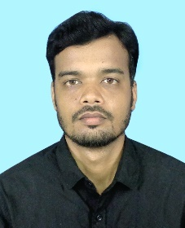
RESUME

PARTHA GHOSH
VILL – BIRSINGPUR
P.O - BENACHAPRA
P.S – GARHBETA Contact No- +919064969811
DIST.- PASCHIM MEDINIPUR E-MAIL-g.partha.agro@gmail.com PIN- 721201 (WB)

FATHER’S NAME : MALIN GHOSH
DATE OF BIRTH : 14/04/1992
RELIGION : HINDU
CASTE : GEN.
NATIONALITY : INDIAN.
SEX. : MALE(SINGLE).

EDUCATIONAL QUALIFICATION:-

NAME OF THE EXAM. | NAME OF THE RECOGNIZE BOARD / UNIVERSITY | YEAR OF PASSING | % OF MARKS
B.Sc(Agriculture) | Dr. B.R. AMBEDKAR UNIVERSITY | 2015 | 63%
10TH +2 Agriculture | W.B.S.C.V.E.T | 2011 | 69%
Madhyamik | W.B.B.S.E | 2009 | 45%

OTHERS QUALIFICATION:- Basic Computer Knowledge in MS Office & Internet Surfing.

HOBBY : LISTENING MUSIC, PHOTOGRAPHY, TRAVELLING

LANGUAGE KNOWN : BENGALI, ENGLISH, HINDI.

WORKING EXPERIENCE :
Company-Green Field Material Handling Pvt. Ltd.
WORK- Salse Representative (Agriculture Equipments)
Duration- 3Years
Working Area- Karnataka and Tamilnadu
Declaration
I, the undersigned do hereby declare that all of the above statements are true and correct to the best of my knowledge.

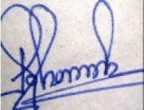

Date : 31/08/2021
Place : West Bengal ________________________
(Signature)

