RESUME
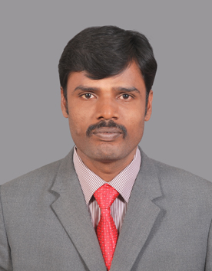
M.SIVARAJ
301 NEW CHITRAMBALAM LAY OUT
PONNI NAGAR
PAPPANAICKEN PALAYAM MOBILE: 97895-00022
COIMBATORE – 641 037.
email.sivarajcbe32@yahoo.com

OBJECTIVE: To obtain a post in Customer Care, Service Engineer and Supervising Official in an Engineering Industry.

ACADEMICAL DATA
COURSE INST. YEAR CLASS

S.S.L.C Govt.High School MAR’1993 II
Cbe

I.T.I - Suguna Inst. Of JUL’1995 I
Automobile Engg Technology

B.Com Annamalai Dec’2001 II
University

CERTIFIED QUALIFICATIONS

1.Trained as a Apprentice Worker in Cheran Transport Corp Ltd, Coimbatore from 28.02.1996 to 27.02.1997. – Class Obtained – I
2.Short time Course in Computer from Sethupathi I.T.I, Coimbatore – Class Obtained – II
OTHER QUALIFICATION
1.OBTAINED License from Tamil Nadu Pollution Control Board, Chennai
2. Two Wheeler and Four Wheeler Driving License Holder
3. Workability in Computerized atmosphere.
4. Fluent knowledge in Tamil and English

EXPERIENCE

- Worked as a Work man Mechanic with Demo in N.Mahalingam & Co., Coimbatore from May’1997 to Mar’2004 (Tractor Balvan & Tempo Traveler Trax & Three Wheeler.

- Worked as a Marketing Executive in Trident Dynamics Ltd, Coimbatore from Mar’2004 to Jan’2005 (Power Tiller Sales & Service).Varun Power Tiller

- Worked as a Sales Officer in ABT Four Wheeler Division from Jan’2005 to Nov 2005

- Worked in Indoshell TVS Dealer as a Assistant Service Manager from Dec 2005 to Apr 2010

- worked in M/s. N.Mahalingam & Co as a Customer Care Executive from May 2010 toMar 2011

- Worked in Ampere Vehicles Pvt Ltd as a Area service Engineer Form Mar 2011to Jan 2018(Manuf in Electric Bikes OE Company)

- At present working in KCP Engineers Pvt Ltd as a Assistant Manager Transport Form Mar 2018 to till.

*Handling customers and Dealers in Tamilnadu.
*Providing training to dealer about vehicles details.
*Problem solving capability.

LAST SALARY DRAWN : Rs. 20500+ Allowance

EXPECTED SALARY : NAG

PERSONAL DATA

DATE OF BIRTH : 29.04.1976

FATHER’S NAME : P.Muthusamy

NATIONALITY : Indian

RELIGION CUM COMMUNITY : Hindu – Kulala

MARITIAL STATUS : Married

DECLARATION

I hereby declare that above stated information are true to my best of knowledge and belief.

M.SIVARAJ

STATION: COIMBATORE

DATE :

