RESUME

i
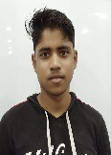  MD HARUN UR RASHID  Mob-6294641722  09732432272  EMAIL-rhmnmkl@gmail.com |  | OBJECTIVE  A position in an esteemed organization that would offer me the opportunity to use my skill and towards organizational goals and self-development.  Educational Qualification
Permanent address:- | EXAMINATION |  | BOARD | YEAR OF PASSING | PERCENTAGE
Vill+po-Sargachi,PS- | MADHYAMIK |  | WBBME | 2015 | 65.25
Beldanga,Dist-Murshidabad
Beldanga,Dist-Murshidabad | HS |  | WBBSE | 2017 | 62.2
,WestBengal
Personal Data | TECHNICAL QUALIFICATION
Father Name-Md Rowshan Ali | EXAMINATION |  | BOARD | YEAR OF PASSING | PERCENTAGE
Father Name-Md Rowshan Ali | ITI |  | NCVT 2019 |  | 81
Mother Name-Rashida Bibi
DOB-25thFeb,2000
SEX-Male
Caste-OBC
Nationality-Indian |  | COMPUTER QUALIFICATION
Language-Bengali,Hindi,English
BloodGroup- |  | - BASICCOMPUTERCOURSE
Hobby-Playing Cricket |  | - TALLY
 |  | - MS-OFFICE
 |  | - E-COMMERCE
 |  | - M-COMMERCE
 |  | WORKING EXPERIENCE
 |  | 3 YEARS EXPERIENCE IN ZENIAK INNOVATION INDIA LIMITED.
 |  | As a Sales & Service Engineer.

I hereby declare that the above-mentioned information is true to the Best of my knowledge.

PLACE- 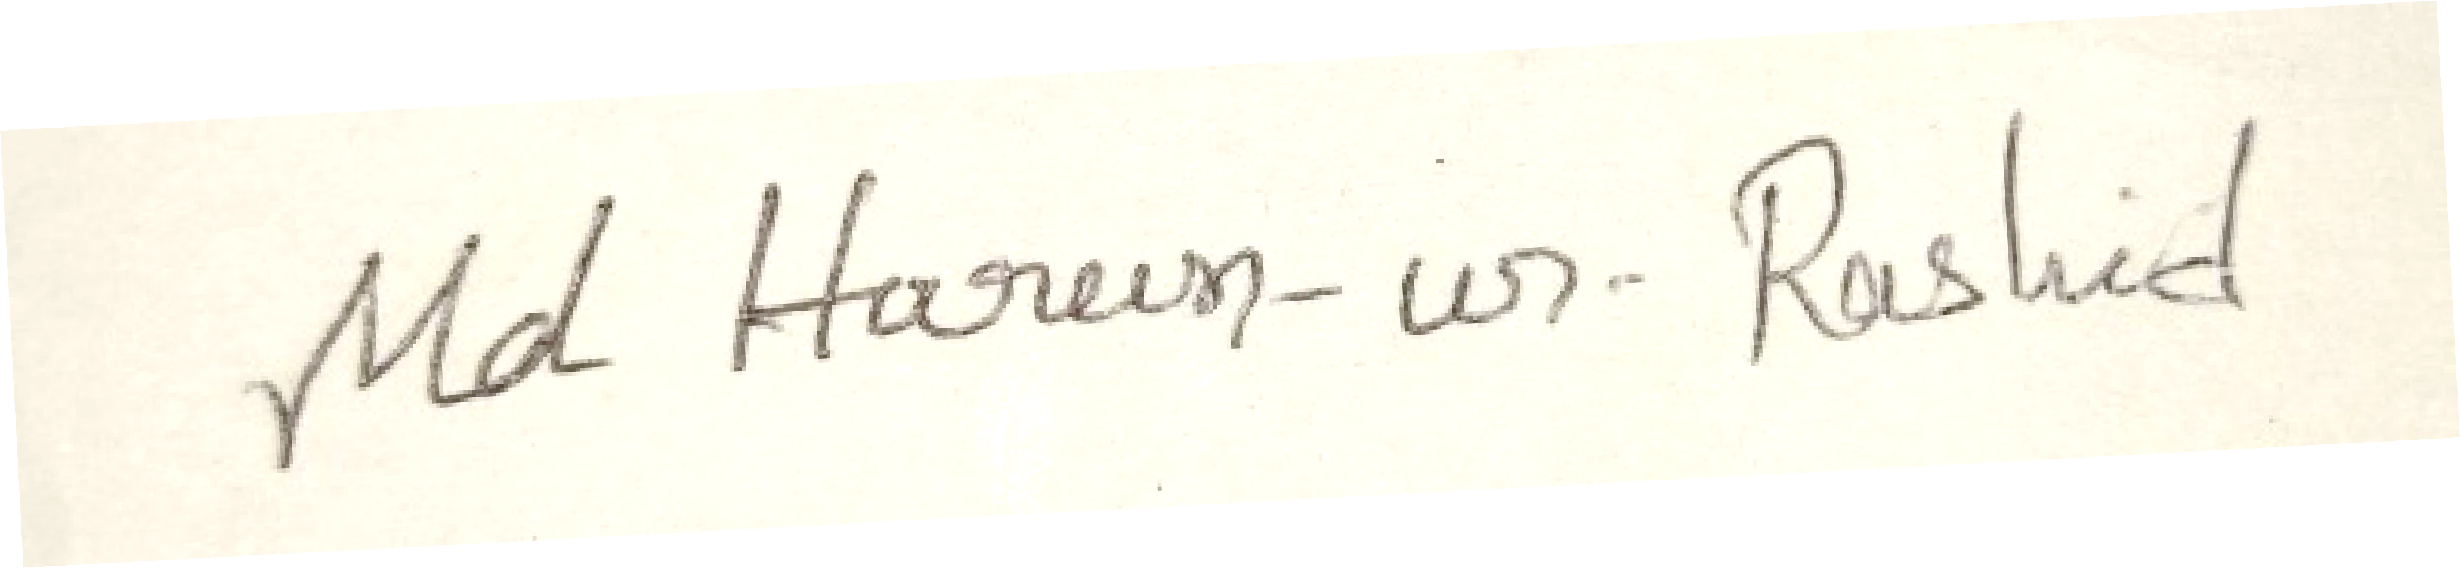DATE- SIGNATURE

